Приложение №2
к рабочей программе
Муниципальное бюджетное общеобразовательное учреждение средняя общеобразовательная школа №4 с.Верхнеяркеево муниципального района
Илишевский район Республики Башкортостан

Утверждаю

Директор МБОУ СОШ №4 с. Верхнеяркеево
_______Хакимова С.М.
Приказ № 248
от«31» августа 2022г.

Контрольно-измерительные материалы

промежуточной аттестации и критерии оценивания

Уровень общего образования: ____5-9_классы__
Предмет: ___англйский язык___
Класс: ___6_класс___

Составитель: Мухамадуллина Л.Р.

с.Верхнеяркеево,2022

6 класс
Контрольно- измерительный материал (включены задания ОГЭ)
1 четверть
Контрольное аудирование
Задание 1. Послушай четыре рассказа. Установи соответствие между рассказом каждого говорящего и видами путешествий. В задании указан один лишний вид путешествия. Ты услышишь рассказы дважды. Занесисвоиответывтаблицу.
A. Travelling by plane В. Travelling by car С. Travelling by train
D. A hiking trip E. A cycling trip
Speaker I | Speaker 2 | Speaker 3 | Speaker 4
 |  |  | .

Задание 2. Посмотри на картинку. Послушай разговор Индиры и Марка. Найди на картинке друзей Индиры. Соедини стрелками их имена и изображения. Ты услышишь разговор дважды.
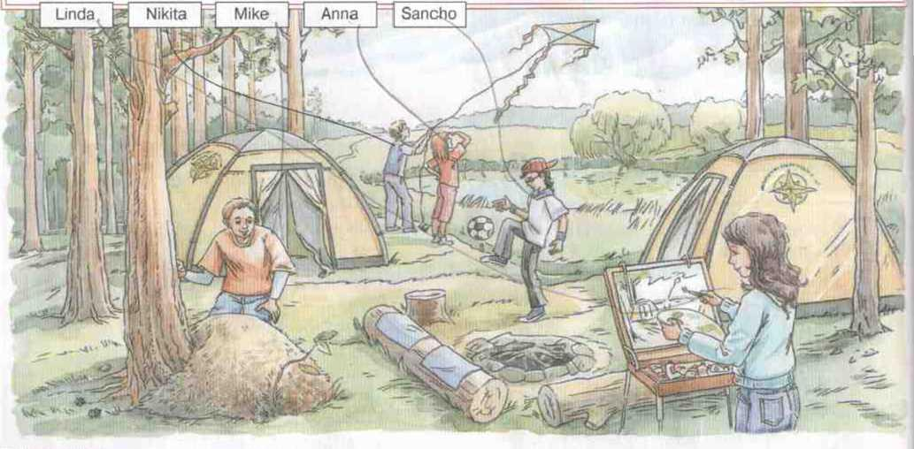
Контрольное чтение
Прочитай текст и выполни задания 1,2,3 London
Great Britain October 17th
Dear Ann.
Thank you for your letter. It was great to get some news from you.
I have already been at home for a week because of the flu. I can't say that I am having a good time, but I’m trying to enjoy myself.
I’m reading an interesting book about Mel Fisher. Have you ever heard of him? He was an explorer and a treasure hunter¹.
When he was a boy, his favourite book was Treasure Island. Mel dreamed about travelling round the world, exciting adventures and treasure².
When Mel grew up, he didn’t forget about his dream. It took him 16 years of hard work. He looked for treasure from the Nuestra Senora de Atocha and the Santa Margarita: Spanish ships which had sunk³ in 1662, near Florida. Every day Mel said, ‘Today is the day!” But only in 1985 Mel and his team found over 40 tons of silver and gold. There were Spanish coins, gold bars, wonderful decorations, royal plates and dishes and other historical things.
Mel gave part of the found treasure to a museum which was then named the Mel Fisher's Treasure Museum. Nowadays this museum in Florida is very popular among children and teenagers who like stories about pirates and their treasure.
Later Mel Fisher found some more ships, which were full of different historical works of art and so he has become a famous person. Nobody else has found so many tantastic and valuable things.
Would you like to find treasure? What would you do with the treasure you found?
I would like to take part in the expedition of treasure hunters and find a bag full of reasure. But I haven’t decided what I would do with the treasure.
Have you got a dream? Do you believe that it can come true? The book about Mel Fisher says it's possible.
Sorry, but I have to finish the letter. The doctor has come.
Write back, please.
Best wishes,
Andrew
Задание 1. Найди и отметь верный ответ на вопрос. Обведи соответствующую букву.
What is the text about?
a) An unusual museum b) a famous explorer c) A well-known writer d) A Spanish ship
Задание2. Закончи предложения, выбрав правильный вариант из предложенных. Обведи соответствующую букву.
1) In his childhood Mel Fisher wanted
A. to become a writer.
B. to build a ship.
C. to find treasure.
D. to open a shop.
2) Fisher’s dream came true after
- many years of hard work.
- after a tour round the world.
- a visit to a museum.
- discovery of the book.
3) Mel Fisher became famous because
- he wrote Treasure Island.
- he went round the world.
- he found some old ships.
- he opened a museum
Задание 3. Прочитай предложения. Отметь предложения, которые соответствуют тексту,— Т (true), и предложения, которые не соответствуют тексту,— F (false).
- The adventure books played an important role in Fisher’s life.
- Mel Fisher was the captain of two big Spanish ships.
- Mel Fisher looked for treasure alone.
- You can see some of Fisher’s treasure in a museum.
Контрольное письмо
Задание. Заполни анкету для поступления в международный клуб путешественников.
International Explorers' Club
Name___________________________________________________
Surname_________________________________________________
Age_____________________________________________________
Country__________________________________________________
Languages you speak Hobbies________________________________
Favourite subjects__________________________________________
Countries (places) you would like to visit_____

Приложение №2
к рабочей программе
Муниципальное бюджетное общеобразовательное учреждение средняя общеобразовательная школа №4 с.Верхнеяркеево муниципального района
Илишевский район Республики Башкортостан

Утверждаю

Директор МБОУ СОШ №4 с. Верхнеяркеево
_______Хакимова С.М.
Приказ № 248
от«31» августа 2022г.

Контрольно-измерительные материалы

промежуточной аттестации и критерии оценивания

Уровень общего образования: ____5-9_классы__
Предмет: ___англйский язык___
Класс: ___7_класс___

Составитель: Мухамадуллина Л.Р.

с.Верхнеяркеево,2022

7 класс

Контрольная работа 1 четверть (включены задания ВПР)
- Аудирование (стр. 31)
- Чтение (стр. 31-32)
3. Match the words with theirs translations.
- Humorous a. Возможный
- Scientific b. Успешный
- Chemical c. Нервный
- Cunning d. Ответственный
- Naughty e. Опасный
- Successful f. Хитрый
- Nervous g. Вредный
- Possible h. Забавный
- Responsible i. Научный
- Dangerous j. Химический

4. Fill in the gaps with each other or one another

1. John and Mary looked at . I would say he looked at her with admiration.
2. Peter and Susan have met .
3. Elka,Yvonne and Joanna gave a book.
4. Three children talked to .They stood next to my house.
5. I and my uncle talk to every day. Although his character isn't easy to bear.

5. Make the parsing of the sentences, using The Present Simple, The Past Simple or the Future Simple

1.I (go) to bed at ten o'clock every day.
2. I (go) to bed at ten o'clock yesterday.
3. I (go) to bed at ten o'clock tomorrow.
4. My brother (read) detective stories every day.
5. He (leave) home at a quarter past eight yesterday.
6. Напишите цифры словами.
1) 5,886 2) 56,982 3) 1896 4) 45-6789-8462 5) 765,926,967

For tasks 1-6, you can get 35 points.
35-33 points – Well done!
32-29 points- Good!
28- 24 points – sat!
23 points or less- Bad!

Приложение №2
к рабочей программе
Муниципальное бюджетное общеобразовательное учреждение средняя общеобразовательная школа №4 с.Верхнеяркеево муниципального района
Илишевский район Республики Башкортостан

Утверждаю

Директор МБОУ СОШ №4 с. Верхнеяркеево
_______Хакимова С.М.
Приказ № 248
от«31» августа 2022г.

Контрольно-измерительные материалы

промежуточной аттестации и критерии оценивания

Уровень общего образования: ____5-9_классы__
Предмет: ___англйский язык___
Класс: ___8_класс___

Составитель: Мухамадуллина Л.Р.

с.Верхнеяркеево,2022

8 класс Progress check 1. (включены задания ОГЭ)

Аудирование стр.50
1.Listen to the conversation between Kate and her father. Complete the sentence.
2. Listen to the weather forecast.
3. Listen to the information broadcast by the local radio.
Чтение стр. 51
Read the text and mark the statements below as T, F,NS.
Грамматика
1. Choose the words which best completes the sentences.
1) The man was shaking … anger. A) from B) to C) with
2) He was … hurt during the flood. A) well B) seriously C) quietly
3) The drought did a lot of … to the city. A) problems B) disasters C) damage
4) Have you finished your research … this subject? A) on B) in C) of
5) He had done the test … 5 o’clock. A) in B) by C) on
2. Put the verbs into Past Continuous, Past Perfect, Past Simple.
1) The Browns … (leave) for Moscow a month ago.
2) Boys … (ride) their bikes at 4 o’clock yesterday.
3) We … (arrive) at the theatre before the performance … (begin).
4) Sam … (do) his homework from 5 to 6.
5) When I … (phone), Ann … already (clean) her parrot’s cage.
3. Find the odd word.
1) wet, humid, rainy, dry
2) rainy, stormy, windy, hot
3) lovely, nice, awful, wonderful
4) interesting, exciting, boring, funny
5) astronaut, satellite, space, ton
4. Correct grammar mistakes.
1) I had reading a magazine by 6 o’clock.
2) They have written a test by that time.
3) While he were sleeping, Helen phoned him.
4) She was play chess at 5 o’clock.
5. Write the forms of the irregular verbs: кусаться, вести машину, находить, слышать, знать.
6*. Translate into English.
1) Мой брат и мухи не обидит. 2) Мальчики пожали друг другу руки. 3) Наводнение причинило много вреда. 4) Это было ужасное бедствие. 5) Сегодня жарко и сыро. 6) Галактика – это огромная группа звезд и планет.
Критерии оценивания для 8 а, б, в классов:
45-42 баллов – «отлично»
41-35 баллов – «хорошо»
34- 27 баллов – «удовлетворительно»
26- ниже – «плохо»

Приложение №2
к рабочей программе
Муниципальное бюджетное общеобразовательное учреждение средняя общеобразовательная школа №4 с.Верхнеяркеево муниципального района
Илишевский район Республики Башкортостан

Утверждаю

Директор МБОУ СОШ №4 с. Верхнеяркеево
_______Хакимова С.М.
Приказ № 248
от«31» августа 2022г.

Контрольно-измерительные материалы

промежуточной аттестации и критерии оценивания

Уровень общего образования: ____5-9_классы__
Предмет: ___англйский язык___
Класс: ___9_класс___

Составитель: Мухамадуллина Л.Р.

с.Верхнеяркеево,2022

Progress check 1 9 класс (включены задания ОГЭ)
- Listening
Listen to the text and write T fo True, F for False.
- The writer went to the theatre._______
- He cried all the way through the new film.______
- This restaurant does actually exist.______
- The owner of the restaurant was very angry with the director.______
- In the film in the restaurant everything goes right.______
- The film company paid her much money.______
- Jane was afraid that people will stop coming.______
- She decided to contact with famous magazine._______
II. Fill in articles, where is necessary.
- How many bridges were there in … London at …beginning of … 11th century?
- Did you travel to …North?
- We had …wonderful time in … Windsor Safary Park?
- … Mr.West lives in … small town in … west of … England.
- Do you like to travel by … plane or by … car?
- Where is … Red Square?
III. Choose the right option and fill in the gaps.
1. You shouldn’t be rude to people who are trying to help you. … advice if you don’t like it, but behave yourself.
a) ignore b) deserve c) confess d)follow
2. Nobody except us knew about the plan. It means that the person who …us is here in this room.
a) had betrayed b ) betray c)has betrayed d)was betrayed
3. I envy her because she is so good at languages. She … Italian for only a year and can already speak it perfectly.
a) have been learning b) had learnt c) has been learning d)was learning
4. When the fire began, I found out that the door was locked. It was my roommate who … me from the fire.
a) rescued b) has rescued c) had been rescuing d) rescues
5. Wherever we live and … language we speak we all need friends.
a) whoever b) however c) whatever d) whenever
IV. Read the words and find their definitions.
1) a chatterbox a) to behave dishonestly towards a person who believes you
2) a bore b) it’s hard to believe
3) to appreciate c) to be grateful for something
4) to betray d) someone who is boring
5) to deserve e) to have a bad feeling towards somebody
6) to envy f)someone who talks too much
7) incredible g) to earn something by actions
V. Choose the right answer.
1) He ___ in the garden when Tom ___. A) sat; was coming B) was sitting; came
2) I ___ a message from Kelly last Saturday. A) have got B) got
3) My mother wasn’t at the shop when I ___. A) had come B) came
4) For long month she ___ his secret. A) had been keeping B) had kept
5) Our car ___ at the moment. A) is being cleaned B) is cleaned
6) He doesn’t try hard,___? A) do he B) doesn’t he C) does he
7) His name ___ in the book. A) hasn’t been mentioned B) wasn’t mentioned
8) I think he ___ the address already. A) has found B) has been found
9) There is nobody there,___? A) is there B) isn’t there C) does there
10) Mary has just written a letter,___? A) has she B) doesn’t she C) hasn’t she

